First steps in a degree project supported by Canvas

Gerald Q. Maguire Jr.

We will assume that a student (named “Quentin FakeStudent”) is interested in doing a degree project and that this student is already in the Canvas system. We will also assume that initially this student is **not** enrolled in a degree project course **nor** is the student in a Canvas course room for a degree project course.

This student fills out a form (yet to be defined) that collects some basic information that can be used by someone working in the School’s education office to determine if the student is eligible to start a degree project. If the student is not eligible they are referred to student advising. If the student is eligible, the student is added to a suitable Canvas course room for their degree project. Here we assume that there is one such course room at each school for each of 1st and 2nd cycle degree project students. In the material that follows we will assume that this student is in some degree program administered by KTH’s School of Electrical Engineering and Computer Science. This process is shown in Figure 1‑1.

|  |
| --- |
| A |

Figure 1‑1: First steps leading to student being added to Canvas course room

Once the student is added to the Canvas course room (at point A in Figure 1‑1) we can utilize Canvas to help with the rest of the degree project process as described in Section 2. However, before this point we should consider if it is possible to help with the process *before* a student is added to the Canvas course, we consider the question: How can Canvas help with this process? This processing is described in Section 1.

# Before a student is added to a Canvas course room

When the Master’s coordinator (here after simply “coordinator “) considers whether a student is eligible to start a degree project (illustrated by a diamond in Figure 1‑1), the coordinator will look in Ladok to see if the student meets a number of criteria (such as):

* The student has taken a research methodology course (such as II2202);
* The student has taken a sufficient number of points in their program; and
* When the student completes their degree project they will have met all of the requirements for a degree in the student’s program.

A key aspect to note is that to do this evaluation the coordinator needs to look into Ladok and they need to know the student’s program of study (and a specialization if one exists). Fortunately, Ladok has this information about the student’s program of study (and a specialization if one exists). Therefore, I wrote a small little program to enable the coordinator to add this data to Canvas[1], so that others could use this data. (Specifically, the dynamic survey can make use of this data.) At some point later in time (when Ladok and Canvas synchronize) there should be an automated addition/update of this data in Canvas.

Figure 1‑1 shows the state of a number of users’ custom data. In this case, Ann, Bertil, and Karolin have program data stored. (Note that this is in a Canvas course with course_id=2.)

|  |
| --- |
| **./custom-data-for-users-in-course.py -C 2**  using HTTP for the container environment  user name=Ann FakeStudent with id=3 and sis_id=z1  result of getting custom data for user Ann FakeStudent is {'data': {'programs': [{'code': 'CDATE', 'name': 'Degree Programme in Computer Science and Engineering', 'major': 'Datalogi och datateknik', 'start': '2016'}]}}  user name=Bertil FakeStudent with id=4 and sis_id=z2  result of getting custom data for user Bertil FakeStudent is {'data': {'programs': [{'code': 'CINTE', 'name': 'Degree Programme in Information and Communication Technology', 'major': 'Elektroteknik', 'track': 'IND', 'start': '2018'}]}}  user name=Cenric FakeStudent with id=5 and sis_id=z3  result of getting custom data for user Cenric FakeStudent is []  user name=David FakeStudent with id=6 and sis_id=z4  result of getting custom data for user David FakeStudent is []  user name=Ellen FakeStudent with id=7 and sis_id=z5  result of getting custom data for user Ellen FakeStudent is []  user name=Fran FakeStudent with id=8 and sis_id=z6  result of getting custom data for user Fran FakeStudent is []  user name=Gordon FakeStudent with id=9 and sis_id=z7  result of getting custom data for user Gordon FakeStudent is []  user name=Håkan FakeStudent with id=10 and sis_id=z8  result of getting custom data for user Håkan FakeStudent is []  user name=Ibǘy FakeStudent with id=11 and sis_id=z9  result of getting custom data for user Ibǘy FakeStudent is []  user name=James FakeStudent with id=12 and sis_id=z10  result of getting custom data for user James FakeStudent is []  user name=Karolin FakeStudent with id=13 and sis_id=z11  result of getting custom data for user Karolin FakeStudent is {'data': {'programs': [{'code': 'TIVNM', 'name': "Master's Programme, ICT Innovation, 120 credits", 'major': 'Datalogi och datateknik', 'track': 'DASC', 'start': '2018'}]}}  user name=Lucy FakeStudent with id=14 and sis_id=z12  result of getting custom data for user Lucy FakeStudent is []  … |

Figure 1‑1: Status of student's custom user data

A new navigation button called “AdminIT” has been added to a Canvas degree project course as shown in Figure 1‑2.

|  |
| --- |
|  |

Figure 1‑2: New left navigation menu with aAdmiIT button

Clicking on the AdminIT button involes an external LTI tool “adminit.rb running locally at TCP port 3598. This configuration of the app is shown in Figure 1‑3.

|  |
| --- |
|  |

Figure 1‑3: AdminIT app configuration

Figure 1‑4 shows the AdminIT process. As can be seen in the figure the major choices are Delete a student from a program, Add a student to a program, Enroll a student in a degree project course, and process the next student. Later, Figure 1‑6 shows how the user makes these selections.

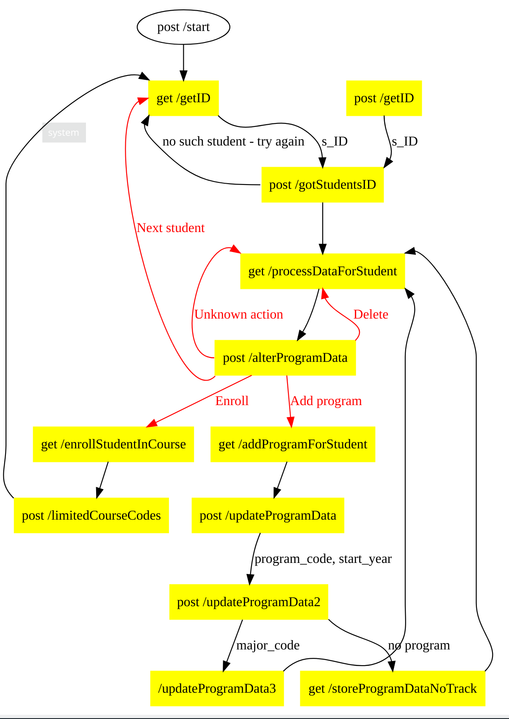

Figure 1‑4: AdminIT process

When this LTI tool is invoked[2], the user will be shown the form in Figure 1‑5. The user enters the sis_id (which in the case of the production Canvas system is a user’s KTHID).

|  |
| --- |
|  |

Figure 1‑5: '/getID' form

If we enter z12, the sis_id for the user Lucy, we see the form shown in Figure 1‑6.

|  |
| --- |
|  |

Figure 1‑6: Choose Lucy's program

The coordinator can now select which program Lucy is in – from a pull-down menu[3] as shown in Figure 1‑7. Next the coordinator is also prompted to enter the year that the student started in this program. Note that the alternatives are the last 10 years.

|  |
| --- |
|  |

Figure 1‑7: Choose CINTE program from the menu

Next the coordinator is prompted to enter the major subject for Lucy, as shown in Figure 1‑8.

|  |
| --- |
|  |

Figure 1‑8: Indicate the student’s major subject)

If the program has specialization/tracks the coordinator will be prompted to choose the specialization (track) from another pull-down menu.

|  |
| --- |
|  |

Figure 1‑9: Lucy's custom data has been updated

Finally, Lucy’s custom user data is updated as shown in Figure 1‑10.

|  |
| --- |
|  |

Figure 1‑10: Lucy's custom data has been updated

The coordinator can now added to the relevant course room for the degree project course by clicking on the “Enroll” button. The student is added to the course room and the coordinator can now select which alternatives the student can choose from among. These choices are constrained by the programmed constraints. In this case Lucy can choice between one A-F course and one Pass/fail course (as shown in Figure 1‑11).

|  |
| --- |
|  |

Figure 1‑11: Coordinator can now select the alternative courses that Lucy can select from among

Once the coordinate makes the selection and submit it, an entry is made in the grade book that will limit Lucy to choose between these two courses. The two symbols at the start indicate that the student’s choice is restricted.

|  |
| --- |
|  |

Figure 1‑12: Gradebook shows the alternative courses that Lucy can select

When Lucy logs in she can selects the dynamic survey to provide information about her planned degree project (see Figure 1‑12).

|  |
| --- |
|  |

Figure 1‑13: Lucy logs in and clicks on the first module to take the dynamic survey

Lucy will now see the start of the dynamic survey as shown in Figure 1‑14.

|  |
| --- |
|  |

Figure 1‑14: Top of dynamic survey

After filling out this survey, at the bottom of the first form Lucy will see that as a CINTE student she has the choice of a degree project course that is graded A-F or Pass/fail (see Figure 1‑15).

|  |
| --- |
|  |

Figure 1‑15: As a CINTE student, Lucy can choose an A-F or Pass/Fail graded course

We will assume that Lucy has selected the default (Pass/Fail course grading), see will now see the form shown in Figure 1‑18. If she has multiple alternatives, she can select one of them. In this case she has only one alternative.

|  |
| --- |
|  |

Figure 1‑16: Lucy has only one alternative course to select

Next Lucy is prompted to choose a potential examiner for this degree project course (see Figure 1‑17).

|  |
| --- |
|  |

Figure 1‑17: Lucy is prompted to choose a potential examiner

Lucy will now see the form shown in Figure 1‑18 informing her that she has now completed the selection of the degree project course and indicated a potential examiner.

|  |
| --- |
|  |

Figure 1‑18: Lucy has completed the selection of the degree project course and potential examiner

As a side effect of the student completing the dynamic survey, the instructor or administrator can now see in the course’s grade book the information that Lucy entered (as shown in Figure 1‑19). Further explanation of these fields is given in the next section.

|  |
| --- |
|  |

Figure 1‑19: Lucy's entry in the gradebook as viewed by the teacher or administrator

Additionally, the student has been added to the section for their potential examiner and the section called “Awaiting Assignment of Examiner” (as will be described in more detail in the next section).

# Once a student is added to a Canvas course[4]

Once the student is added to the Canvas course room (at point A in Figure 1‑1) we can utilize Canvas to help with the rest of the degree project process. If we look in the Canvas course room at the “People” page, we can see all of the students and teachers in the course – as shown in Figure 2‑1. In this page we can see that Quentin FakeStudent is a “Student” in the course “Test course 5” (this course has the fake course code J5).

|  |
| --- |
|  |

Figure 2‑1: Initial people page - showing students (and teachers) in course

Now that the student being has access to the Canvas course room (which they will make use of for the rest of their degree project course) the next steps are a dynamic survey to collect some basic data about the proposed degree project and some administrative processing as shown in Figure 2‑2.

|  |
| --- |
| G  F  E  D  C  B |

Figure 2‑2: Dynamic survey and Administrative steps in Canvas

After logging into the Canvas course room, the student will take a dynamic survey that will collect the information that was previously collected by the UT-EXAR form. The details of this are described in the thesis:

Reshad Sarwar and Nathan Manzi, *More tools for Canvas : Realizing a Digital Form with Dynamically Presented Questions and Alternatives*. Stockholm, Sweden: KTH, Communication Systems, CoS, 2019, TRITA-EECS-EX-2019:93 [Online]. Available: <http://urn.kb.se/resolve?urn=urn%3Anbn%3Ase%3Akth%3Adiva-251021>

The final page of the survey will confirm that the student has signed up for a given degree project course code and has selected a potential examiner (from among those that are eligible) or they have not chosen a potential examiner. In the case of Quentin FakeStudent, when he completes the dynamic survey he will see a page such as shown in Figure 2‑3.

|  |
| --- |
|  |

Figure 2‑3: After student is added to Canvas course room

As a side effect of the student completing the dynamic survey the student is added to two sections: "Awaiting Assignment of Examiner" and a section for their potential examiner (in this case “Anders Västberg”) (at step B in Figure 2‑2). The student’s membership in these two sections can be seen via the People page, shown in Figure 2‑4.

|  |
| --- |
|  |

Figure 2‑4: People page after the student has completed the dynamic survey

Additionally, the dynamic survey also updated a number of custom columns in the gradebook for the course. These columns are shown in Figure 2‑5, with a zoomed in view in Figure 2‑6.

|  |
| --- |
|  |

Figure 2‑5: Gradebook entry for Quentin - as viewed in the Awaiting Assignment of Examiner section

|  |
| --- |
|  |

Figure 2‑6: Zoomed via of gradebook entry for Quentin - as viewed in the Awaiting Assignment of Examiner section

In Figure 2‑6 we can see that the choice of potential examiner is flagged with a prefix of “⚠⚠”. Similar the course code is also prefixed in the same way so that we know that these are not the definitive values. We can also see that the fields of “Planned_start_date”, “Tentative_Title”, “Prelim_description”, “Place”, “Contact”, and “Student_approval” (to publish full text via DiVA). The values for these fields were collected via the dynamic survey.

A potential supervisor (named “A. B. Normal”) reads the project description and if they are interested registers as the supervisor (at step C in Figure 2‑2) by entering their name in the field for “Supervisor” in the gradebook as shown in Figure 2‑7.

|  |
| --- |
|  |

Figure 2‑7: After adding supervisor (A. B. Normal)

The potential examiner accepts being the examiner by removing the warning symbols (at step D in Figure 2‑2) by editing the field shown in Figure 2‑8 into the value shown in Figure 2‑9.

|  |
| --- |
|  |

Figure 2‑8; Examiner about to accept

|  |
| --- |
|  |

Figure 2‑9: Examiner accepts

The course coordinator confirms the examiner, supervisor, and project (at step E in Figure 2‑2) by removing the student from the "Awaiting Assignment of Examiner" section as shown in Figure 2‑10 to produce the membership shown in Figure 2‑11. The people page now shows the updated section information shown in Figure 2‑12. This student is now longer in the "Awaiting Assignment of Examiner" section as shown in Figure 2‑13.

|  |
| --- |
|  |

Figure 2‑10:Section membership just before course coordinator confirms

|  |
| --- |
|  |

Figure 2‑11: Just after course coordinator confirms

|  |
| --- |
|  |

Figure 2‑12: Updated section membership information

|  |
| --- |
|  |

Figure 2‑13: Gradebook for "Awaiting Assignment of Examiner" section after course coordinator confirms

After registering the student in Ladok for the correct degree project course, the education office removes the two warning signs for the Course_code (or in the worst case corrects the entry) as shown in Figure 2‑14. The resulting entry in the gradebook is now shown in Figure 2‑15.

|  |
| --- |
|  |

Figure 2‑14: Just before registering student in Ladok

|  |
| --- |
|  |

Figure 2‑15: Gradebook after student is registered in Ladok

The student can now begin to prepare the various documents to be delivered in the course of the degree project (starting at step G in Figure 2‑2).

# Using the AdminIT tool for students in multiple programs

Potentially a student might be in one or more programs. While the current prototype does not support students in programs with overlapping time lines, the AdminIT tool does let an administrator add and delete programs for a student who is already in one or more programs of study.

Note that as of July 2019, the interface has changed since the description in the figures in this section. In particular the button “Register” has been renamed “Enroll”, as the action is to enroll the student in the set of students in a Canvas course room.

The following figures show the case of a student (Ibǘy) who is initially part of the CINTE program (as shown in Figure 3‑1) and then is added to the TIVNM program (as shown in Figure 3‑2). At this point the administrator deletes the student from the CINTE program (as shown in Figure 3‑3). Finally, the program data for the student is shown in Figure 3‑4.

|  |
| --- |
|  |

Figure 3‑1: Ibǘy is initially in the CINTE program having started in 2017

|  |
| --- |
|  |

Figure 3‑2: Ibǘy is added to the TIVNM program

|  |
| --- |
|  |

Figure 3‑3: bǘy to be delted from CINTE

|  |
| --- |
|  |

Figure 3‑4: Ibǘy's program data after the deletion

While (as noted earlier) the software is not really prepared to deal with students being in multiple programs, this interface does enable an administrator to correct mistakes – where a student is entered into the incorrect program, the year of starting is incorrect, etc.

# Claiming students as an examiner

ChipIT has been extended (as of 2019.07.08) to make it easy for an examiner to “claim” students, i.e., confirm that they will be the examiner for specific students. In the gradebook as shown in Figure 4‑1, we can see that Ellen has proposed Gerald Q. Maguire Jr. as her examiner (indicated in the gradebook with the prefix “⚠⚠” before the examiner’s name) and that Gordon does not have a complete entry, but does have a course code.

|  |
| --- |
|  |

Figure 4‑1: Initial gradebook

In Figure 4‑2 we can see that Ann, Bertil, Ellen, Gordon, Karolin, and Lucy are awaiting assignments of an examiner. This is shown by their membership in the section “Awaiting Assignment of Examiner”.

|  |
| --- |
|  |

Figure 4‑2: Initial People page

The examiner (in this case Gerald Q. Maguire Jr.) invokes the ChipIT LTI tool as shown in Figure 4‑3. Using this interface he clicks on the button “Claim students” and is shown the page in Figure 4‑4.

|  |
| --- |
|  |

Figure 4‑3: Invoking the ChipIT LTI tool

As can be seen in Figure 4‑4 the examiner is presented with a list containing one student: Ellen. This occurs because Ellen has previously proposed him as her examiner. The examiner claims this student by clicking on the radio button and then clicking “Submit”.

|  |
| --- |
|  |

Figure 4‑4: There is one student who has indicated that she wants the examiner Maguire. The examiner clicks the radio button to select this student and then clicks Submit.

The examiner is now shown a list of students whom are (1) awaiting the assignment of an examiner and (2) that he could be an examiner for (based on the course code that the students have selected and for which the examiner is one of the examiners). Figure 4‑5 shows that there are three such students: Bertil, Lucy, and Gordon.

|  |
| --- |
|  |

Figure 4‑5: There are 3 students that the examiner could be an examiner for (based upon the course codes that these students have selected.

Of these three students, the examiner selects two: Bertil and Gordon. This is done by clicking on the radio buttons for these two students as shown in Figure 4‑6.

|  |
| --- |
|  |

Figure 4‑6: Of the three students, the examiner selects two: Bertil and Gordon

After processing the new gradebook state is shown in Figure 4‑7 and the new People page is shown in Figure 4‑8. In the gradebook we can see that the examiner for Bertil, Ellen, and Gordon is now Gerald Q. Maguire Jr. Note that the prefix “⚠⚠” has been removed – indicating that these students are now claimed by the examiner.

Additionally, we can see that in the people page (Figure 4‑8) these students are no longer in the section “Awaiting Assignment of Examiner” and they have also been removed from the sections for their previously proposed examiner. All of the selected (“claimed”) students are now in the examiner’s section.

|  |
| --- |
|  |

Figure 4‑7: Gradebook after the processing has completed

|  |
| --- |
|  |

Figure 4‑8: People page after the processing has completed

**Implementation note**: The LTI tool must execute with sufficient privileges to be able to create and modify sections as well as enroll students into these sections.

1. As a technical note: This data is being stored in the user’s custom data in the name space: "se.kth.canvas-app.program_of_study".
2. It is only usable by a teacher, administrator, or systems administrator.
3. Note that in all pull-down menus the user must make a actively make a selection – if they do not, it is as if nothing was selected.
4. Note that the figures in this section were made in a different Canvas course room than those in the previous section. Moreover, this section was written earlier than the previous section. As a result the example student data is different.